[](https://www.comsol.com/)

Variante aneurisma1

|  |  |
| --- | --- |
| Report date | Jun 21, 2024, 4:46:07 PM |

Contents

1. Global Definitions

1.1. Parameters

1.2. Shared Properties

1.3. Materials

2. Component 1

2.1. Definitions

2.2. Geometry 1

2.3. Materials

2.4. Laminar Flow

2.5. Mesh 1

3. Study 1

3.1. Stationary

3.2. Solver Configurations

4. Results

4.1. Datasets

4.2. Plot Groups

# Global Definitions

|  |  |
| --- | --- |
| Date | Jun 18, 2024, 5:07:23 PM |

Global settings

|  |  |
| --- | --- |
| Name | Variante aneurisma1.mph |
| Path | C:\Users\user\Desktop\Progetti biomacchine\Variante_aneurisma1.mph |
| Version | COMSOL Multiphysics 6.2 (Build: 339) |
| Unit system | SI |

Used products

|  |
| --- |
| COMSOL Multiphysics |
| CAD Import Module |

Computer information

|  |  |
| --- | --- |
| CPU | Intel64 Family 6 Model 142 Stepping 10, 4 cores, 15.88 GB RAM |
| Operating system | Windows 10 |

## Parameters

Parameters 1

| **Name** | **Expression** | **Value** | **Description** |
| --- | --- | --- | --- |
| Qin | 4.8 [l/min] | 8E−5 m³/s | Portata sanguigna in ingresso nell'aorta ascendente |
| Pout_min | 80 [mmHg] | 10666 Pa | Pressione sanguigna di metà diastole (pressione minima) |
| Pout_max | 120 [mmHg] | 15999 Pa | Pressione sanguigna del picco sistolico (pressione massima) |

## Shared Properties

### Default Model Inputs

|  |  |
| --- | --- |
| Tag | cminpt |

## Materials

### Blood

Basic

| **Description** | **Value** | **Unit** |
| --- | --- | --- |
| Density | 1060 | kg/m³ |
| Dynamic viscosity | 0.0035 | Pa·s |

# Component 1

|  |  |
| --- | --- |
| Date | Jun 17, 2024, 10:15:59 AM |

Settings

| **Description** | **Value** |
| --- | --- |
| Unit system | Same as global system (SI) |
| Geometry shape function | Automatic |

Spatial frame coordinates

| **First** | **Second** | **Third** |
| --- | --- | --- |
| x | y | z |

Material frame coordinates

| **First** | **Second** | **Third** |
| --- | --- | --- |
| X | Y | Z |

Geometry frame coordinates

| **First** | **Second** | **Third** |
| --- | --- | --- |
| Xg | Yg | Zg |

Mesh frame coordinates

| **First** | **Second** | **Third** |
| --- | --- | --- |
| Xm | Ym | Zm |

## Definitions

### Coordinate Systems

#### Boundary System 1

|  |  |
| --- | --- |
| Coordinate system type | Boundary system |
| Tag | sys1 |

Coordinate names

| **First** | **Second** | **Third** |
| --- | --- | --- |
| t1 | t2 | n |

## Geometry 1

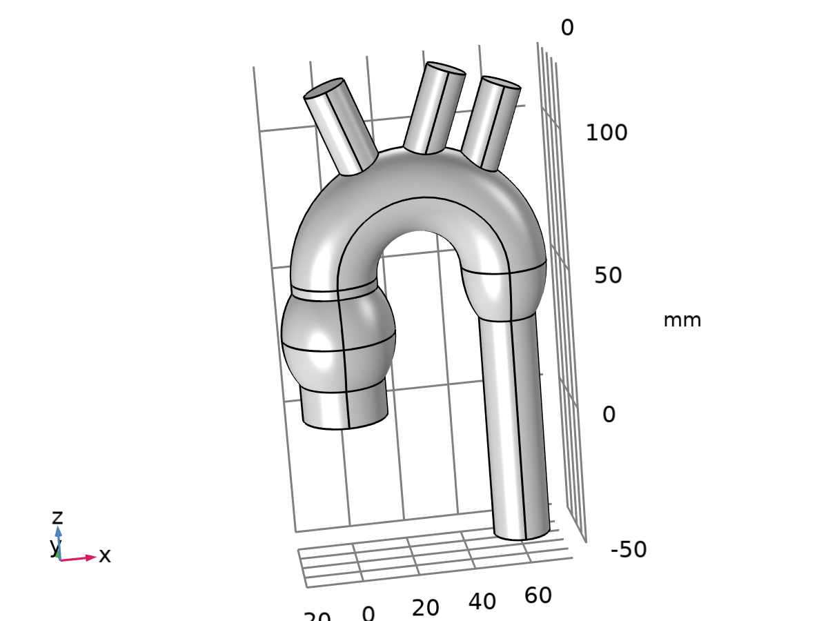

Geometry 1

Units

|  |  |
| --- | --- |
| Length unit | mm |
| Angular unit | deg |

Geometry statistics

| **Description** | **Value** |
| --- | --- |
| Space dimension | 3 |
| Number of domains | 1 |
| Number of boundaries | 45 |
| Number of edges | 99 |
| Number of vertices | 56 |

### Aorta ascendente (wp1)

Unite objects

| **Description** | **Value** |
| --- | --- |
| Unite objects | On |

Information

| **Description** | **Value** |
| --- | --- |
| Last build time | < 1 second |
| Built with | COMSOL 6.2.0.339 (win64), Jun 18, 2024, 3:37:49 PM |

#### Plane Geometry (sequence2D)

##### Circle 1 (c1)

Position

| **Description** | **Value** |
| --- | --- |
| Position | {0, 0} |

Size and shape

| **Description** | **Value** |
| --- | --- |
| Radius | 15 |

Information

| **Description** | **Value** |
| --- | --- |
| Last build time | < 1 second |
| Built with | COMSOL 6.2.0.339 (win64), Jun 17, 2024, 10:23:17 AM |

### Extrude 1 (ext1)

General

| **Description** | **Value** |
| --- | --- |
| Work plane | Aorta ascendente (wp1) |

Distances

| **Distances (mm)** |
| --- |
| 50 |

Scales

| **Scales xw** | **Scales yw** |
| --- | --- |
| 1 | 1 |

Displacements

| **Displacements xw (mm)** | **Displacements yw (mm)** |
| --- | --- |
| 0 | 0 |

Twist angles

| **Twist angles (deg)** |
| --- |
| 0 |

Information

| **Description** | **Value** |
| --- | --- |
| Last build time | < 1 second |
| Built with | COMSOL 6.2.0.339 (win64), Jun 18, 2024, 3:37:49 PM |

### Aorta discendente (wp2)

Unite objects

| **Description** | **Value** |
| --- | --- |
| Unite objects | On |

Information

| **Description** | **Value** |
| --- | --- |
| Last build time | < 1 second |
| Built with | COMSOL 6.2.0.339 (win64), Jun 18, 2024, 3:37:49 PM |

#### Plane Geometry (sequence2D)

##### Circle 1 (c1)

Position

| **Description** | **Value** |
| --- | --- |
| Position | {60, 0} |

Size and shape

| **Description** | **Value** |
| --- | --- |
| Radius | 10 |

Information

| **Description** | **Value** |
| --- | --- |
| Last build time | < 1 second |
| Built with | COMSOL 6.2.0.339 (win64), Jun 17, 2024, 10:29:04 AM |

### Extrude 2 (ext2)

General

| **Description** | **Value** |
| --- | --- |
| Work plane | Aorta discendente (wp2) |

Distances

| **Distances (mm)** |
| --- |
| 100 |

Distances

| **Description** | **Value** |
| --- | --- |
| Reverse direction | On |

Scales

| **Scales xw** | **Scales yw** |
| --- | --- |
| 1 | 1 |

Displacements

| **Displacements xw (mm)** | **Displacements yw (mm)** |
| --- | --- |
| 0 | 0 |

Twist angles

| **Twist angles (deg)** |
| --- |
| 0 |

Information

| **Description** | **Value** |
| --- | --- |
| Last build time | < 1 second |
| Built with | COMSOL 6.2.0.339 (win64), Jun 18, 2024, 3:37:49 PM |

### Arco aortico (wp3)

Unite objects

| **Description** | **Value** |
| --- | --- |
| Unite objects | On |

Information

| **Description** | **Value** |
| --- | --- |
| Last build time | < 1 second |
| Built with | COMSOL 6.2.0.339 (win64), Jun 18, 2024, 3:37:50 PM |

#### Plane Geometry (sequence2D)

##### Circle 1 (c1)

Position

| **Description** | **Value** |
| --- | --- |
| Position | {60, 0} |

Size and shape

| **Description** | **Value** |
| --- | --- |
| Radius | 15 |

Information

| **Description** | **Value** |
| --- | --- |
| Last build time | < 1 second |
| Built with | COMSOL 6.2.0.339 (win64), Jun 17, 2024, 1:01:19 PM |

### Work Plane 4 (wp4)

Plane definition

| **Description** | **Value** |
| --- | --- |
| Plane | zx - plane |

Unite objects

| **Description** | **Value** |
| --- | --- |
| Unite objects | On |

Information

| **Description** | **Value** |
| --- | --- |
| Last build time | < 1 second |
| Built with | COMSOL 6.2.0.339 (win64), Jun 18, 2024, 3:37:50 PM |

#### Plane Geometry (sequence2D)

##### Circular Arc 1 (ca1)

Selections of resulting entities

| **Description** | **Value** |
| --- | --- |
| Resulting objects selection | On |

Settings

| **Description** | **Value** |
| --- | --- |
| Specify | Endpoints and radius |
| Center | {50, 30} |
| Radius | 30 |
| Starting point | {50, 0} |
| Endpoint | {50, 60} |
| Start angle | 270 |
| End angle | 90 |
| Clockwise | On |

Information

| **Description** | **Value** |
| --- | --- |
| Last build time | < 1 second |
| Built with | COMSOL 6.2.0.339 (win64), Jun 17, 2024, 1:19:35 PM |

### Sweep 1 (swe1)

Settings

| **Description** | **Value** |
| --- | --- |
| Create cross-sectional faces | On |
| Include all inputs in Form Union/Assembly | Off |
| Manual control of sweep direction | Off |

Information

| **Description** | **Value** |
| --- | --- |
| Last build time | < 1 second |
| Built with | COMSOL 6.2.0.339 (win64), Jun 18, 2024, 3:37:50 PM |

### Ellipsoid 1 (elp1)

Position

| **Description** | **Value** |
| --- | --- |
| Position | {60, 0, 50} |

Axis

| **Description** | **Value** |
| --- | --- |
| Axis type | z - axis |

Size

| **Description** | **Value** |
| --- | --- |
| a-semiaxis | 15 |
| b-semiaxis | 15 |
| c-semiaxis | 25 |

Information

| **Description** | **Value** |
| --- | --- |
| Last build time | < 1 second |
| Built with | COMSOL 6.2.0.339 (win64), Jun 18, 2024, 3:37:50 PM |

### Work Plane 5 (wp5)

Plane definition

| **Description** | **Value** |
| --- | --- |
| Plane type | Transformed |
| Displacement | {0, 0, 80} |
| Axis type | yw - axis |
| Rotation angle | -20 |

Unite objects

| **Description** | **Value** |
| --- | --- |
| Unite objects | On |

Information

| **Description** | **Value** |
| --- | --- |
| Last build time | < 1 second |
| Built with | COMSOL 6.2.0.339 (win64), Jun 18, 2024, 3:37:50 PM |

#### Plane Geometry (sequence2D)

##### Circle 1 (c1)

Position

| **Description** | **Value** |
| --- | --- |
| Position | {15, 0} |

Size and shape

| **Description** | **Value** |
| --- | --- |
| Radius | 7.5 |

Information

| **Description** | **Value** |
| --- | --- |
| Last build time | < 1 second |
| Built with | COMSOL 6.2.0.339 (win64), Jun 17, 2024, 3:56:55 PM |

### Work Plane 6 (wp6)

Plane definition

| **Description** | **Value** |
| --- | --- |
| Plane type | Transformed |
| Displacement | {0, 0, 100} |
| Axis type | yw - axis |
| Rotation angle | 20 |

Unite objects

| **Description** | **Value** |
| --- | --- |
| Unite objects | On |

Information

| **Description** | **Value** |
| --- | --- |
| Last build time | < 1 second |
| Built with | COMSOL 6.2.0.339 (win64), Jun 18, 2024, 3:37:50 PM |

#### Plane Geometry (sequence2D)

##### Circle 1 (c1)

Position

| **Description** | **Value** |
| --- | --- |
| Position | {35, 0} |

Size and shape

| **Description** | **Value** |
| --- | --- |
| Radius | 7 |

Information

| **Description** | **Value** |
| --- | --- |
| Last build time | < 1 second |
| Built with | COMSOL 6.2.0.339 (win64), Jun 18, 2024, 1:48:05 PM |

##### Circle 2 (c2)

Position

| **Description** | **Value** |
| --- | --- |
| Position | {55, 0} |

Size and shape

| **Description** | **Value** |
| --- | --- |
| Radius | 7 |

Information

| **Description** | **Value** |
| --- | --- |
| Last build time | < 1 second |
| Built with | COMSOL 6.2.0.339 (win64), Jun 18, 2024, 1:52:19 PM |

### Extrude 3 (ext3)

General

| **Description** | **Value** |
| --- | --- |
| Work plane | Work Plane 5 (wp5) |

Distances

| **Distances (mm)** |
| --- |
| 35 |

Scales

| **Scales xw** | **Scales yw** |
| --- | --- |
| 1 | 1 |

Displacements

| **Displacements xw (mm)** | **Displacements yw (mm)** |
| --- | --- |
| 0 | 0 |

Twist angles

| **Twist angles (deg)** |
| --- |
| 0 |

Information

| **Description** | **Value** |
| --- | --- |
| Last build time | < 1 second |
| Built with | COMSOL 6.2.0.339 (win64), Jun 18, 2024, 3:37:50 PM |

### Extrude 4 (ext4)

General

| **Description** | **Value** |
| --- | --- |
| Work plane | Work Plane 6 (wp6) |

Distances

| **Distances (mm)** |
| --- |
| 35 |

Scales

| **Scales xw** | **Scales yw** |
| --- | --- |
| 1 | 1 |

Displacements

| **Displacements xw (mm)** | **Displacements yw (mm)** |
| --- | --- |
| 0 | 0 |

Twist angles

| **Twist angles (deg)** |
| --- |
| 0 |

Information

| **Description** | **Value** |
| --- | --- |
| Last build time | < 1 second |
| Built with | COMSOL 6.2.0.339 (win64), Jun 18, 2024, 3:37:50 PM |

### Union 1 (uni1)

Compose

| **Description** | **Value** |
| --- | --- |
| Keep interior boundaries | Off |

Information

| **Description** | **Value** |
| --- | --- |
| Last build time | < 1 second |
| Built with | COMSOL 6.2.0.339 (win64), Jun 18, 2024, 3:37:50 PM |

### Ellipsoid 2 (elp2)

Position

| **Description** | **Value** |
| --- | --- |
| Position | {0, 0, 30} |

Axis

| **Description** | **Value** |
| --- | --- |
| Axis type | z - axis |

Size

| **Description** | **Value** |
| --- | --- |
| a-semiaxis | 20 |
| b-semiaxis | 20 |
| c-semiaxis | 25 |

Information

| **Description** | **Value** |
| --- | --- |
| Last build time | < 1 second |
| Built with | COMSOL 6.2.0.339 (win64), Jun 18, 2024, 3:48:40 PM |

### Union 2 (uni2)

Compose

| **Description** | **Value** |
| --- | --- |
| Keep interior boundaries | Off |

Information

| **Description** | **Value** |
| --- | --- |
| Last build time | < 1 second |
| Built with | COMSOL 6.2.0.339 (win64), Jun 18, 2024, 4:05:11 PM |

### Form Union (fin)

Information

| **Description** | **Value** |
| --- | --- |
| Details | {Formed union of 1 solid object., Union has 1 domain, 45 boundaries, 99 edges, and 56 vertices.} |
| Last build time | < 1 second |
| Built with | COMSOL 6.2.0.339 (win64), Jun 18, 2024, 4:06:22 PM |

## Materials

### Blood

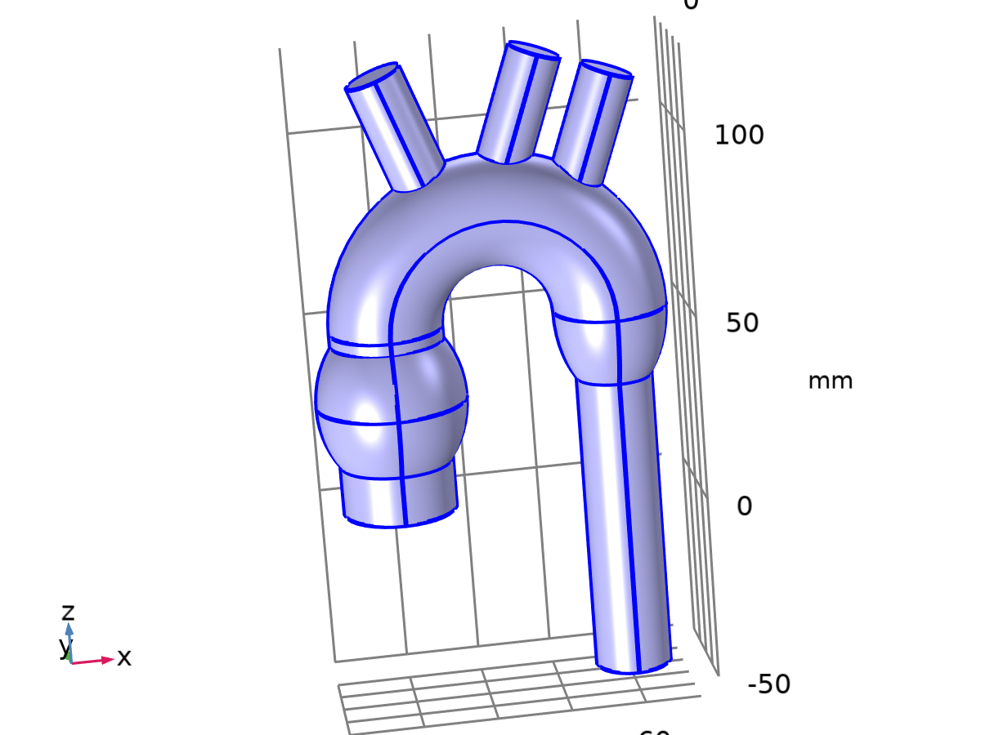

Blood

Selection

|  |  |
| --- | --- |
| Geometric entity level | Domain |
| Selection | Geometry geom1: Dimension 3: All domains |

Material parameters

| **Name** | **Value** | **Unit** | **Property group** |
| --- | --- | --- | --- |
| Density | 1060 | kg/m³ | Basic |
| Dynamic viscosity | 0.0035 | Pa·s | Basic |

Basic

| **Description** | **Value** | **Unit** |
| --- | --- | --- |
| Density | 1060 | kg/m³ |
| Dynamic viscosity | 0.0035 | Pa·s |

## Laminar Flow

Used products

|  |
| --- |
| COMSOL Multiphysics |



Laminar Flow

Selection

|  |  |
| --- | --- |
| Geometric entity level | Domain |
| Selection | Geometry geom1: Dimension 3: All domains |

Equations





### Interface Settings

#### Discretization

Settings

| **Description** | **Value** |
| --- | --- |
| Discretization of fluids | P1 + P1 |

Settings

| **Description** | **Value** |
| --- | --- |
| Equation form | Study controlled |

#### Physical Model

Settings

| **Description** | **Value** | **Unit** |
| --- | --- | --- |
| Neglect inertial term (Stokes flow) | Off |  |
| Compressibility | Incompressible flow |  |
| Enable porous media domains | Off |  |
| Include gravity | Off |  |
| Reference temperature | User defined |  |
| Reference temperature | 293.15 | K |
| Reference pressure level | 1.0133E5 | Pa |

#### Turbulence

Settings

| **Description** | **Value** |
| --- | --- |
| Turbulence model type | None |

### Variables

| **Name** | **Expression** | **Unit** | **Description** | **Selection** | **Details** |
| --- | --- | --- | --- | --- | --- |
| spf.Tref | model.input.Tref | K | Reference temperature | Global | Meta |
| spf.dz | 1 | m | Thickness | Domain 1 |  |
| spf.pref | 1[atm] | Pa | Reference pressure level | Domain 1 |  |
| spf.pA | p+spf.pref | Pa | Absolute pressure | Domain 1 |  |
| spf.hasWF | 0 |  | Help variable | Boundaries 1–45 |  |
| spf.dt_CFL | 1/max(spf.maxop(sqrt(emetric_spatial(u-d(x,TIME),v-d(y,TIME),w-d(z,TIME)))),eps) | s | Time step, CFL=1 | Global |  |
| spf.Qvd_tot | spf.intop(spf.Qvd) | W | Total viscous dissipation | Global |  |
| spf.K_stressx | spf.K_stress_tensorxx*spf.nxmesh+spf.K_stress_tensorxy*spf.nymesh+spf.K_stress_tensorxz*spf.nzmesh | N/m² | Viscous stress, exterior boundaries, x-component | Boundaries 1–45 |  |
| spf.K_stressy | spf.K_stress_tensoryx*spf.nxmesh+spf.K_stress_tensoryy*spf.nymesh+spf.K_stress_tensoryz*spf.nzmesh | N/m² | Viscous stress, exterior boundaries, y-component | Boundaries 1–45 |  |
| spf.K_stressz | spf.K_stress_tensorzx*spf.nxmesh+spf.K_stress_tensorzy*spf.nymesh+spf.K_stress_tensorzz*spf.nzmesh | N/m² | Viscous stress, exterior boundaries, z-component | Boundaries 1–45 |  |
| spf.T_stressx | spf.T_stress_tensorxx*spf.nxmesh+spf.T_stress_tensorxy*spf.nymesh+spf.T_stress_tensorxz*spf.nzmesh | N/m² | Total traction, exterior boundaries, x-component | Boundaries 1–45 |  |
| spf.T_stressy | spf.T_stress_tensoryx*spf.nxmesh+spf.T_stress_tensoryy*spf.nymesh+spf.T_stress_tensoryz*spf.nzmesh | N/m² | Total traction, exterior boundaries, y-component | Boundaries 1–45 |  |
| spf.T_stressz | spf.T_stress_tensorzx*spf.nxmesh+spf.T_stress_tensorzy*spf.nymesh+spf.T_stress_tensorzz*spf.nzmesh | N/m² | Total traction, exterior boundaries, z-component | Boundaries 1–45 |  |
| spf.K_stress_dx | down(spf.K_stress_tensorxx)*spf.dnxmesh+down(spf.K_stress_tensorxy)*spf.dnymesh+down(spf.K_stress_tensorxz)*spf.dnzmesh | N/m² | Viscous stress, interior boundaries, downside, x-component | Boundaries 1–45 |  |
| spf.K_stress_dy | down(spf.K_stress_tensoryx)*spf.dnxmesh+down(spf.K_stress_tensoryy)*spf.dnymesh+down(spf.K_stress_tensoryz)*spf.dnzmesh | N/m² | Viscous stress, interior boundaries, downside, y-component | Boundaries 1–45 |  |
| spf.K_stress_dz | down(spf.K_stress_tensorzx)*spf.dnxmesh+down(spf.K_stress_tensorzy)*spf.dnymesh+down(spf.K_stress_tensorzz)*spf.dnzmesh | N/m² | Viscous stress, interior boundaries, downside, z-component | Boundaries 1–45 |  |
| spf.T_stress_dx | down(spf.T_stress_tensorxx)*spf.dnxmesh+down(spf.T_stress_tensorxy)*spf.dnymesh+down(spf.T_stress_tensorxz)*spf.dnzmesh | N/m² | Total traction, interior boundaries, downside, x-component | Boundaries 1–45 |  |
| spf.T_stress_dy | down(spf.T_stress_tensoryx)*spf.dnxmesh+down(spf.T_stress_tensoryy)*spf.dnymesh+down(spf.T_stress_tensoryz)*spf.dnzmesh | N/m² | Total traction, interior boundaries, downside, y-component | Boundaries 1–45 |  |
| spf.T_stress_dz | down(spf.T_stress_tensorzx)*spf.dnxmesh+down(spf.T_stress_tensorzy)*spf.dnymesh+down(spf.T_stress_tensorzz)*spf.dnzmesh | N/m² | Total traction, interior boundaries, downside, z-component | Boundaries 1–45 |  |
| spf.usePseudoTimeStepping | isrunningpseudotimestepping | 1 | Help variable | Global |  |
| spf.localCFLvalue | 1.3^min(niterCMP,9)+if(niterCMP>=25,9*1.3^min(-25+niterCMP,9),0)+if(niterCMP>=45,90*1.3^min(-45+niterCMP,9),0) |  | Local CFL number | Domain 1 |  |
| spf.locCFL | max(CFLCMP,sqrt(eps)) | 1 | Local CFL number | Global |  |
| spf.geometryLengthScale | 0.009999999999999998 | m | Geometry length scale | Domain 1 |  |
| spf.time_step_inv | max(sqrt(emetric_spatial(u,v,w)*2^gmg_level^2),spf.nu/spf.geometryLengthScale^2) | Hz | Inverse time step | Domain 1 |  |
| spf.tsti | nojac(spf.time_step_inv/spf.locCFL) | 1/s | Help variable | Domain 1 |  |
| spf.nx | dnx | 1 | Normal vector, x-component | Boundaries 1–45 |  |
| spf.ny | dny | 1 | Normal vector, y-component | Boundaries 1–45 |  |
| spf.nz | dnz | 1 | Normal vector, z-component | Boundaries 1–45 |  |
| spf.nxmesh | dnxmesh | 1 | Normal vector, x-component | Boundaries 1–45 |  |
| spf.nymesh | dnymesh | 1 | Normal vector, y-component | Boundaries 1–45 |  |
| spf.nzmesh | dnzmesh | 1 | Normal vector, z-component | Boundaries 1–45 |  |

### Fluid Properties 1



Fluid Properties 1

Selection

|  |  |
| --- | --- |
| Geometric entity level | Domain |
| Selection | Geometry geom1: Dimension 3: All domains |

Equations

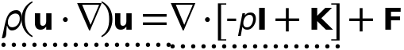



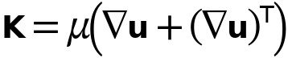

#### Fluid Properties

Settings

| **Description** | **Value** |
| --- | --- |
| Density | From material |
| Constitutive relation | Specify dynamic viscosity |
| Dynamic viscosity | From material |

#### Model Input

Settings

| **Description** | **Value** |
| --- | --- |
| Temperature | Common model input |

Properties from material

| **Property** | **Material** | **Property group** |
| --- | --- | --- |
| Density | Blood | Basic |
| Dynamic viscosity | Blood | Basic |

#### Variables

| **Name** | **Expression** | **Unit** | **Description** | **Selection** | **Details** |
| --- | --- | --- | --- | --- | --- |
| spf.nu | spf.mu/spf.rho | m²/s | Kinematic viscosity | Domain 1 |  |
| spf.mu | material.mu | Pa·s | Dynamic viscosity | Domain 1 | Meta |
| spf.rho | subst(material.rho,spf.fp1.minput_temperature,spf.Trho,spf.fp1.minput_pressure,spf.prho) | kg/m³ | Density | Domain 1 | Meta |
| spf.Trho | spf.Tref | K | Temperature for density evaluation | Domain 1 |  |
| spf.prho | spf.pref | Pa | Pressure for the evaluation of density | Domain 1 |  |
| spf.rhoref | subst(material.rho,spf.fp1.minput_temperature,spf.Tref,spf.fp1.minput_pressure,spf.pref) | kg/m³ | Reference density | Domain 1 | Meta |
| spf.mumat | material.mu | Pa·s | Dynamic viscosity | Domain 1 | Meta |
| spf.srijxx | ux | 1/s | Strain rate tensor, xx-component | Domain 1 |  |
| spf.srijyx | 0.5*(vx+uy) | 1/s | Strain rate tensor, yx-component | Domain 1 |  |
| spf.srijzx | 0.5*(wx+uz) | 1/s | Strain rate tensor, zx-component | Domain 1 |  |
| spf.srijxy | 0.5*(uy+vx) | 1/s | Strain rate tensor, xy-component | Domain 1 |  |
| spf.srijyy | vy | 1/s | Strain rate tensor, yy-component | Domain 1 |  |
| spf.srijzy | 0.5*(wy+vz) | 1/s | Strain rate tensor, zy-component | Domain 1 |  |
| spf.srijxz | 0.5*(uz+wx) | 1/s | Strain rate tensor, xz-component | Domain 1 |  |
| spf.srijyz | 0.5*(vz+wy) | 1/s | Strain rate tensor, yz-component | Domain 1 |  |
| spf.srijzz | wz | 1/s | Strain rate tensor, zz-component | Domain 1 |  |
| spf.rrijxx | 0 | 1/s | Rotation rate tensor, xx-component | Domain 1 |  |
| spf.rrijyx | 0.5*(vx-uy) | 1/s | Rotation rate tensor, yx-component | Domain 1 |  |
| spf.rrijzx | 0.5*(wx-uz) | 1/s | Rotation rate tensor, zx-component | Domain 1 |  |
| spf.rrijxy | 0.5*(uy-vx) | 1/s | Rotation rate tensor, xy-component | Domain 1 |  |
| spf.rrijyy | 0 | 1/s | Rotation rate tensor, yy-component | Domain 1 |  |
| spf.rrijzy | 0.5*(wy-vz) | 1/s | Rotation rate tensor, zy-component | Domain 1 |  |
| spf.rrijxz | 0.5*(uz-wx) | 1/s | Rotation rate tensor, xz-component | Domain 1 |  |
| spf.rrijyz | 0.5*(vz-wy) | 1/s | Rotation rate tensor, yz-component | Domain 1 |  |
| spf.rrijzz | 0 | 1/s | Rotation rate tensor, zz-component | Domain 1 |  |
| spf.sr | sqrt(2*spf.srijxx^2+2*spf.srijxy^2+2*spf.srijxz^2+2*spf.srijyx^2+2*spf.srijyy^2+2*spf.srijyz^2+2*spf.srijzx^2+2*spf.srijzy^2+2*spf.srijzz^2+eps) | 1/s | Shear rate | Domain 1 |  |
| spf.rr | sqrt(2*spf.rrijxx^2+2*spf.rrijxy^2+2*spf.rrijxz^2+2*spf.rrijyx^2+2*spf.rrijyy^2+2*spf.rrijyz^2+2*spf.rrijzx^2+2*spf.rrijzy^2+2*spf.rrijzz^2+eps) | 1/s | Rotation rate | Domain 1 |  |
| spf.divu | ux+vy+wz | 1/s | Divergence of velocity field | Domain 1 |  |
| spf.Fx | 0 | N/m³ | Volume force, x-component | Domain 1 | + operation |
| spf.Fy | 0 | N/m³ | Volume force, y-component | Domain 1 | + operation |
| spf.Fz | 0 | N/m³ | Volume force, z-component | Domain 1 | + operation |
| spf.U | sqrt(u^2+v^2+w^2) | m/s | Velocity magnitude | Domain 1 |  |
| spf.vorticityx | wy-vz | 1/s | Vorticity field, x-component | Domain 1 |  |
| spf.vorticityy | -wx+uz | 1/s | Vorticity field, y-component | Domain 1 |  |
| spf.vorticityz | vx-uy | 1/s | Vorticity field, z-component | Domain 1 |  |
| spf.vort_magn | sqrt(spf.vorticityx^2+spf.vorticityy^2+spf.vorticityz^2) | 1/s | Vorticity magnitude | Domain 1 |  |
| spf.cellRe | 0.25*spf.rho*sqrt(emetric_spatial(u-d(x,TIME),v-d(y,TIME),w-d(z,TIME))/emetric2_spatial)/spf.mu | 1 | Cell Reynolds number | Domain 1 |  |
| spf.betaT | 0 | 1/Pa | Isothermal compressibility coefficient | Domain 1 |  |
| spf.Qm | 0 | kg/(m³·s) | Source term | Domain 1 | + operation |
| spf.Fgtotx | 0 | N/m³ | Gravity force, x-component | Domain 1 | + operation |
| spf.Fgtoty | 0 | N/m³ | Gravity force, y-component | Domain 1 | + operation |
| spf.Fgtotz | 0 | N/m³ | Gravity force, z-component | Domain 1 | + operation |
| spf.Qm_aco | 0 | kg/(m³·s) | Acoustic mass source | Domain 1 |  |
| spf.F_acox | 0 | N/m³ | Acoustic volume force, x-component | Domain 1 |  |
| spf.F_acoy | 0 | N/m³ | Acoustic volume force, y-component | Domain 1 |  |
| spf.F_acoz | 0 | N/m³ | Acoustic volume force, z-component | Domain 1 |  |
| spf.gamma_sr | sqrt(2*spf.srijxx^2+2*spf.srijxy^2+2*spf.srijxz^2+2*spf.srijyx^2+2*spf.srijyy^2+2*spf.srijyz^2+2*spf.srijzx^2+2*spf.srijzy^2+2*spf.srijzz^2+eps) | 1/s | Shear rate | Domain 1 |  |
| spf.mu_eff | spf.mu+spf.muT | Pa·s | Effective dynamic viscosity | Domain 1 |  |
| spf.muT | 0 | Pa·s | Turbulent dynamic viscosity | Domain 1 | + operation |
| spf.T_stress_tensorxx | spf.K_stress_tensorxx-p | N/m² | Total stress tensor, xx-component | Domain 1 | + operation |
| spf.T_stress_tensoryx | spf.K_stress_tensoryx | N/m² | Total stress tensor, yx-component | Domain 1 | + operation |
| spf.T_stress_tensorzx | spf.K_stress_tensorzx | N/m² | Total stress tensor, zx-component | Domain 1 | + operation |
| spf.T_stress_tensorxy | spf.K_stress_tensorxy | N/m² | Total stress tensor, xy-component | Domain 1 | + operation |
| spf.T_stress_tensoryy | spf.K_stress_tensoryy-p | N/m² | Total stress tensor, yy-component | Domain 1 | + operation |
| spf.T_stress_tensorzy | spf.K_stress_tensorzy | N/m² | Total stress tensor, zy-component | Domain 1 | + operation |
| spf.T_stress_tensorxz | spf.K_stress_tensorxz | N/m² | Total stress tensor, xz-component | Domain 1 | + operation |
| spf.T_stress_tensoryz | spf.K_stress_tensoryz | N/m² | Total stress tensor, yz-component | Domain 1 | + operation |
| spf.T_stress_tensorzz | spf.K_stress_tensorzz-p | N/m² | Total stress tensor, zz-component | Domain 1 | + operation |
| spf.K_stress_tensorxx | 2*spf.mu_eff*ux | N/m² | Viscous stress tensor, xx-component | Domain 1 | + operation |
| spf.K_stress_tensoryx | spf.mu_eff*(vx+uy) | N/m² | Viscous stress tensor, yx-component | Domain 1 | + operation |
| spf.K_stress_tensorzx | spf.mu_eff*(wx+uz) | N/m² | Viscous stress tensor, zx-component | Domain 1 | + operation |
| spf.K_stress_tensorxy | spf.mu_eff*(uy+vx) | N/m² | Viscous stress tensor, xy-component | Domain 1 | + operation |
| spf.K_stress_tensoryy | 2*spf.mu_eff*vy | N/m² | Viscous stress tensor, yy-component | Domain 1 | + operation |
| spf.K_stress_tensorzy | spf.mu_eff*(wy+vz) | N/m² | Viscous stress tensor, zy-component | Domain 1 | + operation |
| spf.K_stress_tensorxz | spf.mu_eff*(uz+wx) | N/m² | Viscous stress tensor, xz-component | Domain 1 | + operation |
| spf.K_stress_tensoryz | spf.mu_eff*(vz+wy) | N/m² | Viscous stress tensor, yz-component | Domain 1 | + operation |
| spf.K_stress_tensorzz | 2*spf.mu_eff*wz | N/m² | Viscous stress tensor, zz-component | Domain 1 | + operation |
| spf.K_stress_tensor_testxx | 2*spf.mu_eff*test(ux) | N/m² | Viscous stress tensor test, xx-component | Domain 1 | + operation |
| spf.K_stress_tensor_testyx | spf.mu_eff*(test(vx)+test(uy)) | N/m² | Viscous stress tensor test, yx-component | Domain 1 | + operation |
| spf.K_stress_tensor_testzx | spf.mu_eff*(test(wx)+test(uz)) | N/m² | Viscous stress tensor test, zx-component | Domain 1 | + operation |
| spf.K_stress_tensor_testxy | spf.mu_eff*(test(uy)+test(vx)) | N/m² | Viscous stress tensor test, xy-component | Domain 1 | + operation |
| spf.K_stress_tensor_testyy | 2*spf.mu_eff*test(vy) | N/m² | Viscous stress tensor test, yy-component | Domain 1 | + operation |
| spf.K_stress_tensor_testzy | spf.mu_eff*(test(wy)+test(vz)) | N/m² | Viscous stress tensor test, zy-component | Domain 1 | + operation |
| spf.K_stress_tensor_testxz | spf.mu_eff*(test(uz)+test(wx)) | N/m² | Viscous stress tensor test, xz-component | Domain 1 | + operation |
| spf.K_stress_tensor_testyz | spf.mu_eff*(test(vz)+test(wy)) | N/m² | Viscous stress tensor test, yz-component | Domain 1 | + operation |
| spf.K_stress_tensor_testzz | 2*spf.mu_eff*test(wz) | N/m² | Viscous stress tensor test, zz-component | Domain 1 | + operation |
| spf.upwind_helpx | u-d(x,TIME) | m/s | Upwind term, x-component | Domain 1 | + operation |
| spf.upwind_helpy | v-d(y,TIME) | m/s | Upwind term, y-component | Domain 1 | + operation |
| spf.upwind_helpz | w-d(z,TIME) | m/s | Upwind term, z-component | Domain 1 | + operation |
| spf.continuityEquation | spf.rho*spf.divu | kg/(m³·s) | Continuity equation | Domain 1 |  |
| spf.contCoeff | spf.rho | kg/m³ | Help variable | Domain 1 |  |
| spf.tau_vdxx | 2*spf.mu*spf.srijxx | Pa | Viscous stress tensor, xx-component | Domain 1 | + operation |
| spf.tau_vdyx | 2*spf.mu*spf.srijyx | Pa | Viscous stress tensor, yx-component | Domain 1 | + operation |
| spf.tau_vdzx | 2*spf.mu*spf.srijzx | Pa | Viscous stress tensor, zx-component | Domain 1 | + operation |
| spf.tau_vdxy | 2*spf.mu*spf.srijxy | Pa | Viscous stress tensor, xy-component | Domain 1 | + operation |
| spf.tau_vdyy | 2*spf.mu*spf.srijyy | Pa | Viscous stress tensor, yy-component | Domain 1 | + operation |
| spf.tau_vdzy | 2*spf.mu*spf.srijzy | Pa | Viscous stress tensor, zy-component | Domain 1 | + operation |
| spf.tau_vdxz | 2*spf.mu*spf.srijxz | Pa | Viscous stress tensor, xz-component | Domain 1 | + operation |
| spf.tau_vdyz | 2*spf.mu*spf.srijyz | Pa | Viscous stress tensor, yz-component | Domain 1 | + operation |
| spf.tau_vdzz | 2*spf.mu*spf.srijzz | Pa | Viscous stress tensor, zz-component | Domain 1 | + operation |
| spf.Qvd | spf.tau_vdxx*ux+spf.tau_vdxy*uy+spf.tau_vdxz*uz+spf.tau_vdyx*vx+spf.tau_vdyy*vy+spf.tau_vdyz*vz+spf.tau_vdzx*wx+spf.tau_vdzy*wy+spf.tau_vdzz*wz | W/m³ | Viscous dissipation | Domain 1 | + operation |
| spf.epsilon_p | 1 | 1 | Porosity | Domain 1 |  |
| spf.epsilon_p_pos | 1 | 1 | Positive porosity | Domain 1 |  |
| spf.Fst_tensorxx | 0 | N/m² | Surface tension force, xx-component | Domain 1 | + operation |
| spf.Fst_tensoryx | 0 | N/m² | Surface tension force, yx-component | Domain 1 | + operation |
| spf.Fst_tensorzx | 0 | N/m² | Surface tension force, zx-component | Domain 1 | + operation |
| spf.Fst_tensorxy | 0 | N/m² | Surface tension force, xy-component | Domain 1 | + operation |
| spf.Fst_tensoryy | 0 | N/m² | Surface tension force, yy-component | Domain 1 | + operation |
| spf.Fst_tensorzy | 0 | N/m² | Surface tension force, zy-component | Domain 1 | + operation |
| spf.Fst_tensorxz | 0 | N/m² | Surface tension force, xz-component | Domain 1 | + operation |
| spf.Fst_tensoryz | 0 | N/m² | Surface tension force, yz-component | Domain 1 | + operation |
| spf.Fst_tensorzz | 0 | N/m² | Surface tension force, zz-component | Domain 1 | + operation |
| spf.res_u | px+spf.rho*u*ux+spf.rho*v*uy+spf.rho*w*uz-(d(2*ux,x)+d(uy+vx,y)+d(uz+wx,z))*spf.mu-spf.Fx | N/m³ | Equation residual | Domain 1 |  |
| spf.res_v | spf.rho*u*vx+py+spf.rho*v*vy+spf.rho*w*vz-(d(vx+uy,x)+d(2*vy,y)+d(vz+wy,z))*spf.mu-spf.Fy | N/m³ | Equation residual | Domain 1 |  |
| spf.res_w | spf.rho*u*wx+spf.rho*v*wy+pz+spf.rho*w*wz-(d(wx+uz,x)+d(wy+vz,y)+d(2*wz,z))*spf.mu-spf.Fz | N/m³ | Equation residual | Domain 1 |  |
| spf.res_p | spf.rho*spf.divu | kg/(m³·s) | Pressure equation residual | Domain 1 |  |

#### Shape functions

| **Name** | **Shape function** | **Unit** | **Description** | **Shape frame** | **Selection** |
| --- | --- | --- | --- | --- | --- |
| u | Lagrange (Linear) | m/s | Velocity field, x-component | Spatial | Domain 1 |
| v | Lagrange (Linear) | m/s | Velocity field, y-component | Spatial | Domain 1 |
| w | Lagrange (Linear) | m/s | Velocity field, z-component | Spatial | Domain 1 |
| p | Lagrange (Linear) | Pa | Pressure | Spatial | Domain 1 |

#### Weak Expressions

| **Weak expression** | **Integration order** | **Integration frame** | **Selection** |
| --- | --- | --- | --- |
| (p-spf.K_stress_tensorxx)*test(ux)-spf.K_stress_tensorxy*test(uy)-spf.K_stress_tensorxz*test(uz)-spf.K_stress_tensoryx*test(vx)+(p-spf.K_stress_tensoryy)*test(vy)-spf.K_stress_tensoryz*test(vz)-spf.K_stress_tensorzx*test(wx)-spf.K_stress_tensorzy*test(wy)+(p-spf.K_stress_tensorzz)*test(wz) | 2 | Spatial | Domain 1 |
| spf.Fx*test(u)+spf.Fy*test(v)+spf.Fz*test(w) | 2 | Spatial | Domain 1 |
| spf.rho*(-(d(u,x)*u+d(u,y)*v+d(u,z)*w)*test(u)-(d(v,x)*u+d(v,y)*v+d(v,z)*w)*test(v)-(d(w,x)*u+d(w,y)*v+d(w,z)*w)*test(w)) | 2 | Spatial | Domain 1 |
| -spf.continuityEquation*test(p) | 2 | Spatial | Domain 1 |
| spf.streamlinens | 2 | Spatial | Domain 1 |
| spf.crosswindns | 2 | Spatial | Domain 1 |
| if(spf.usePseudoTimeStepping>0,spf.rho*spf.tsti,0)*(-(u-nojac(u))*test(u)-(v-nojac(v))*test(v)-(w-nojac(w))*test(w)) | 2 | Spatial | Domain 1 |

### Initial Values 1



Initial Values 1

Selection

|  |  |
| --- | --- |
| Geometric entity level | Domain |
| Selection | Geometry geom1: Dimension 3: All domains |

#### Initial Values

Settings

| **Description** | **Value** | **Unit** |
| --- | --- | --- |
| Velocity field, x-component | 0 | m/s |
| Velocity field, y-component | 0 | m/s |
| Velocity field, z-component | 0 | m/s |
| Pressure | 0 | Pa |

#### Coordinate System Selection

Settings

| **Description** | **Value** |
| --- | --- |
| Coordinate system | Global coordinate system |

#### Variables

| **Name** | **Expression** | **Unit** | **Description** | **Selection** |
| --- | --- | --- | --- | --- |
| spf.u_initx | 0 | m/s | Velocity field, x-component | Domain 1 |
| spf.u_inity | 0 | m/s | Velocity field, y-component | Domain 1 |
| spf.u_initz | 0 | m/s | Velocity field, z-component | Domain 1 |
| spf.p_init | 0 | Pa | Pressure | Domain 1 |

### Wall 1

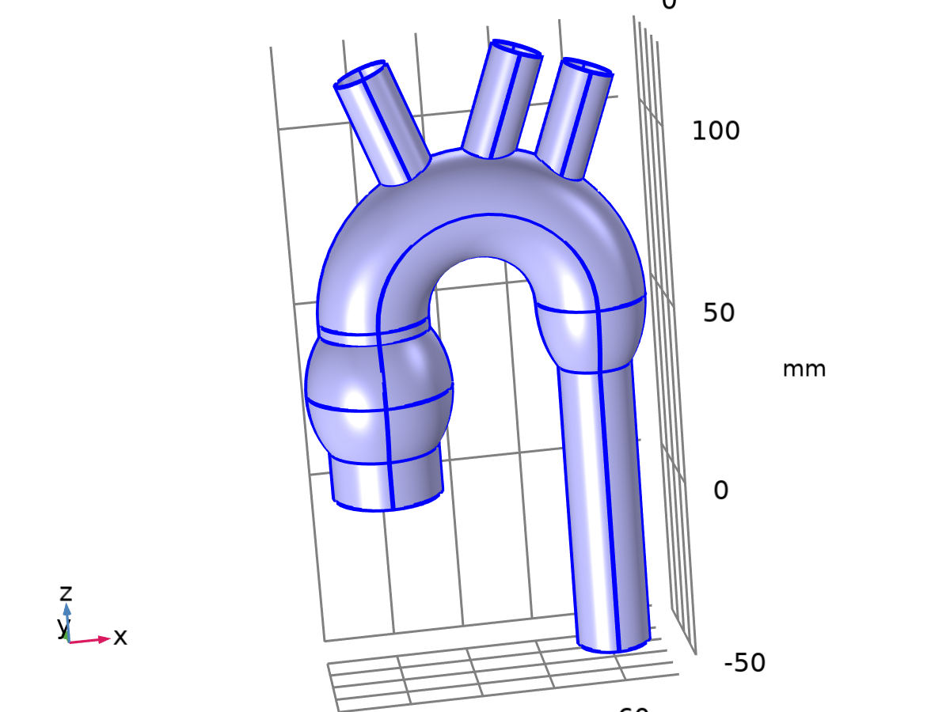

Wall 1

Selection

|  |  |
| --- | --- |
| Geometric entity level | Boundary |
| Selection | Geometry geom1: Dimension 2: All boundaries |

Equations



#### Boundary Condition

Settings

| **Description** | **Value** |
| --- | --- |
| Wall condition | No slip |

#### Wall Movement

Settings

| **Description** | **Value** |
| --- | --- |
| Translational velocity | Automatic from frame |
| Sliding wall | Off |

#### Variables

| **Name** | **Expression** | **Unit** | **Description** | **Selection** | **Details** |
| --- | --- | --- | --- | --- | --- |
| spf.ubndx | spf.utrx+spf.usx | m/s | Velocity at boundary, x-component | Boundaries 1–6, 8–11, 13–30, 32–37, 39–40, 42–45 |  |
| spf.ubndy | spf.utry+spf.usy | m/s | Velocity at boundary, y-component | Boundaries 1–6, 8–11, 13–30, 32–37, 39–40, 42–45 |  |
| spf.ubndz | spf.utrz+spf.usz | m/s | Velocity at boundary, z-component | Boundaries 1–6, 8–11, 13–30, 32–37, 39–40, 42–45 |  |
| spf.usx | 0 | m/s | Velocity of sliding wall, x-component | Boundaries 1–6, 8–11, 13–30, 32–37, 39–40, 42–45 |  |
| spf.usy | 0 | m/s | Velocity of sliding wall, y-component | Boundaries 1–6, 8–11, 13–30, 32–37, 39–40, 42–45 |  |
| spf.usz | 0 | m/s | Velocity of sliding wall, z-component | Boundaries 1–6, 8–11, 13–30, 32–37, 39–40, 42–45 |  |
| spf.utrx | 0 | m/s | Velocity of moving wall, x-component | Boundaries 1–6, 8–11, 13–30, 32–37, 39–40, 42–45 |  |
| spf.utry | 0 | m/s | Velocity of moving wall, y-component | Boundaries 1–6, 8–11, 13–30, 32–37, 39–40, 42–45 |  |
| spf.utrz | 0 | m/s | Velocity of moving wall, z-component | Boundaries 1–6, 8–11, 13–30, 32–37, 39–40, 42–45 |  |
| spf.uLeakagex | 0 | m/s | Leakage velocity, x-component | Boundaries 1–6, 8–11, 13–30, 32–37, 39–40, 42–45 | + operation |
| spf.uLeakagey | 0 | m/s | Leakage velocity, y-component | Boundaries 1–6, 8–11, 13–30, 32–37, 39–40, 42–45 | + operation |
| spf.uLeakagez | 0 | m/s | Leakage velocity, z-component | Boundaries 1–6, 8–11, 13–30, 32–37, 39–40, 42–45 | + operation |
| spf.noSlipWall | 1 | 1 | Help variable | Boundaries 1–6, 8–11, 13–30, 32–37, 39–40, 42–45 |  |

#### Constraints

| **Constraint** | **Constraint force** | **Shape function** | **Selection** | **Details** |
| --- | --- | --- | --- | --- |
| -u+spf.ubndx+spf.uLeakagex | test(-u) | Lagrange (Linear) | Boundaries 1–6, 8–11, 13–30, 32–37, 39–40, 42–45 | Elemental |
| -v+spf.ubndy+spf.uLeakagey | test(-v) | Lagrange (Linear) | Boundaries 1–6, 8–11, 13–30, 32–37, 39–40, 42–45 | Elemental |
| -w+spf.ubndz+spf.uLeakagez | test(-w) | Lagrange (Linear) | Boundaries 1–6, 8–11, 13–30, 32–37, 39–40, 42–45 | Elemental |

### Inlet 1

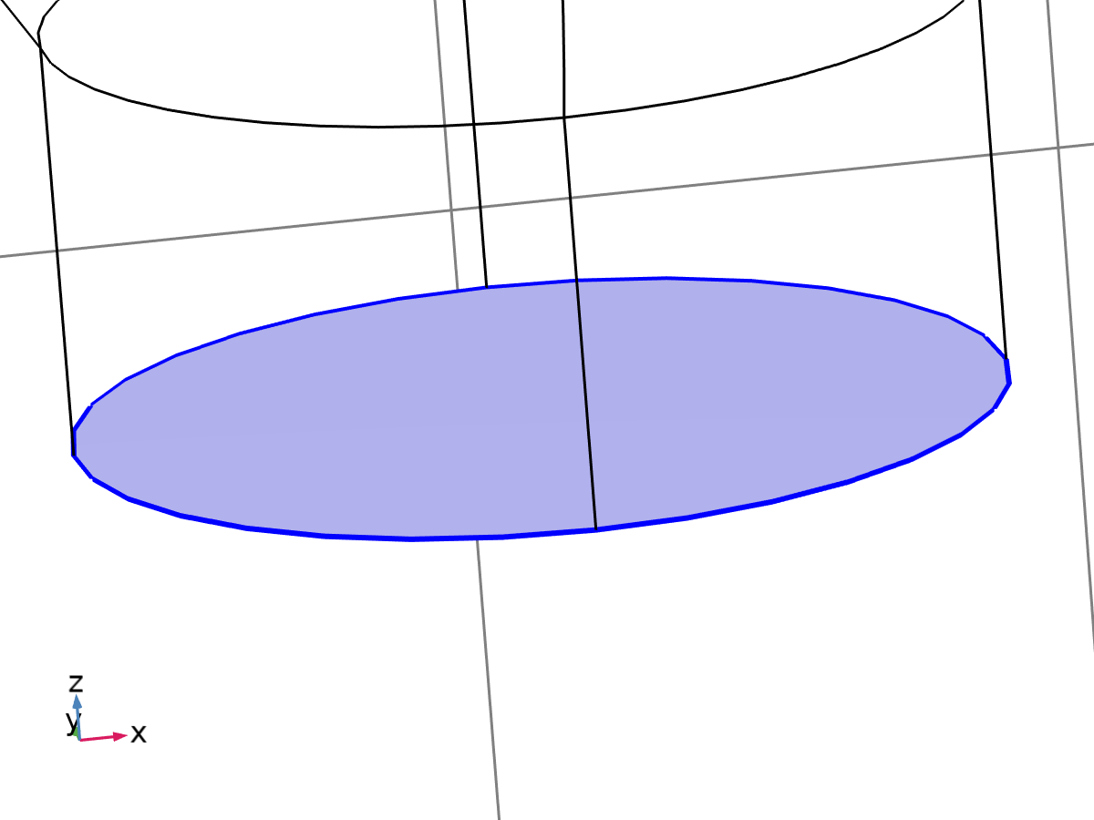

Inlet 1

Selection

|  |  |
| --- | --- |
| Geometric entity level | Boundary |
| Selection | Geometry geom1: Dimension 2: Boundary 7 |

Equations

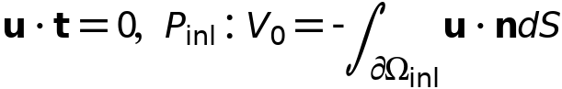

#### Boundary Condition

Settings

| **Description** | **Value** |
| --- | --- |
| Boundary condition | Fully developed flow |
| Apply condition on each disjoint selection separately | On |

#### Fully Developed Flow

Settings

| **Description** | **Value** | **Unit** |
| --- | --- | --- |
| Fully developed flow option | Flow rate |  |
| Flow rate | Qin | m³/s |

#### Variables

| **Name** | **Expression** | **Unit** | **Description** | **Selection** |
| --- | --- | --- | --- | --- |
| spf.nu | spf.mu/spf.rho | m²/s | Kinematic viscosity | Boundary 7 |
| spf.KStressn_avx | spf.K_stress_tensorxx*spf.nxmesh+spf.K_stress_tensorxy*spf.nymesh+spf.K_stress_tensorxz*spf.nzmesh | N/m² | Average viscous stress, x-component | Boundary 7 |
| spf.KStressn_avy | spf.K_stress_tensoryx*spf.nxmesh+spf.K_stress_tensoryy*spf.nymesh+spf.K_stress_tensoryz*spf.nzmesh | N/m² | Average viscous stress, y-component | Boundary 7 |
| spf.KStressn_avz | spf.K_stress_tensorzx*spf.nxmesh+spf.K_stress_tensorzy*spf.nymesh+spf.K_stress_tensorzz*spf.nzmesh | N/m² | Average viscous stress, z-component | Boundary 7 |
| spf.KStressTestn_avx | spf.K_stress_tensor_testxx*spf.nxmesh+spf.K_stress_tensor_testxy*spf.nymesh+spf.K_stress_tensor_testxz*spf.nzmesh | N/m² | Average viscous stress, x-component | Boundary 7 |
| spf.KStressTestn_avy | spf.K_stress_tensor_testyx*spf.nxmesh+spf.K_stress_tensor_testyy*spf.nymesh+spf.K_stress_tensor_testyz*spf.nzmesh | N/m² | Average viscous stress, y-component | Boundary 7 |
| spf.KStressTestn_avz | spf.K_stress_tensor_testzx*spf.nxmesh+spf.K_stress_tensor_testzy*spf.nymesh+spf.K_stress_tensor_testzz*spf.nzmesh | N/m² | Average viscous stress, z-component | Boundary 7 |
| spf.ujumpx | spf.ut_herex-spf.ut_therex | m/s | Velocity jump, x-component | Boundary 7 |
| spf.ujumpy | spf.ut_herey-spf.ut_therey | m/s | Velocity jump, y-component | Boundary 7 |
| spf.ujumpz | spf.ut_herez-spf.ut_therez | m/s | Velocity jump, z-component | Boundary 7 |
| spf.meshVol | meshvol_spatial | m² |  | Boundary 7 |
| spf.meshVolInt | down(meshvol_spatial) | m³ | Volume of interior mesh element | Boundary 7 |
| spf.c_here | 36*nojac(down((spf.mu+spf.muT)/spf.epsilon_p))*spf.meshVol/spf.meshVolInt | Pa·s/m | Intermediate variable | Boundary 7 |
| spf.sigma_dg_ns | 4*spf.c_here | kg/(m²·s) |  | Boundary 7 |
| spf.inl1.V0fdf | Qin | m³/s | Flow rate | Global |
| spf.inl1.dz | spf.dz | m | Channel thickness | Boundary 7 |
| spf.un_here | u*nojac(spf.nxmesh)+v*nojac(spf.nymesh)+w*nojac(spf.nzmesh) | m/s | Intermediate variable | Boundary 7 |
| spf.ut_herex | u-spf.un_here*nojac(spf.nxmesh) | m/s | Intermediate variable, x-component | Boundary 7 |
| spf.ut_herey | v-spf.un_here*nojac(spf.nymesh) | m/s | Intermediate variable, y-component | Boundary 7 |
| spf.ut_herez | w-spf.un_here*nojac(spf.nzmesh) | m/s | Intermediate variable, z-component | Boundary 7 |
| spf.un_there | 0 | m/s | Intermediate variable | Boundary 7 |
| spf.ut_therex | -spf.un_there*nojac(spf.nxmesh) | m/s | Intermediate variable, x-component | Boundary 7 |
| spf.ut_therey | -spf.un_there*nojac(spf.nymesh) | m/s | Intermediate variable, y-component | Boundary 7 |
| spf.ut_therez | -spf.un_there*nojac(spf.nzmesh) | m/s | Intermediate variable, z-component | Boundary 7 |
| spf.unTestx | (test(u)*spf.nxmesh+test(v)*spf.nymesh+test(w)*spf.nzmesh)*spf.nxmesh | m/s |  | Boundary 7 |
| spf.unTesty | (test(u)*spf.nxmesh+test(v)*spf.nymesh+test(w)*spf.nzmesh)*spf.nymesh | m/s |  | Boundary 7 |
| spf.unTestz | (test(u)*spf.nxmesh+test(v)*spf.nymesh+test(w)*spf.nzmesh)*spf.nzmesh | m/s |  | Boundary 7 |
| spf.inl1.pHydroCompensation | 0 | Pa | Hydrostatic pressure | Global |
| spf.d | 1 |  | Length | Boundary 7 |
| spf.inl1.L | 10*sqrt(spf.inl1.intop(1)) | m | Entrance length | Global |
| spf.inl1.side | 7 |  | Help variable | Edge 6 |
| spf.inl1.side | 7 |  | Help variable | Edge 7 |
| spf.inl1.side | 7 |  | Help variable | Edge 23 |
| spf.inl1.side | 7 |  | Help variable | Edge 30 |
| spf.inl1.side_down | 7 |  | Help variable | Edge 6 |
| spf.inl1.side_down | 7 |  | Help variable | Edge 7 |
| spf.inl1.side_down | 7 |  | Help variable | Edge 23 |
| spf.inl1.side_down | 7 |  | Help variable | Edge 30 |
| spf.inl1.volumeFlowRate | spf.inl1.intop(u*spf.nxmesh+v*spf.nymesh+w*spf.nzmesh) | m³/s | Outward volume flow rate across feature selection | Global |
| spf.inl1.massFlowRate | spf.inl1.intop(spf.rho*(u*spf.nxmesh+v*spf.nymesh+w*spf.nzmesh)) | kg/s | Outward mass flow rate across feature selection | Global |
| spf.inl1.pAverage | spf.inl1.aveop(p) | Pa | Pressure average over feature selection | Global |
| spf.inl1.Vinlfdf | -spf.inl1.volumeFlowRate | m³/s | Boundary integral of velocity | Global |
| spf.inl1.Area | spf.inl1.intop(spf.d) | m² | Boundary area | Global |

#### Shape functions

| **Name** | **Shape function** | **Unit** | **Description** | **Shape frame** | **Selection** |
| --- | --- | --- | --- | --- | --- |
| spf.inl1.Pinlfdf | ODE | Pa | Help ode variable for fully developed flow |  | Global |

#### Weak Expressions

| **Weak expression** | **Integration order** | **Integration frame** | **Selection** |
| --- | --- | --- | --- |
| spf.KStressn_avx*test(spf.ut_herex)+spf.KStressn_avy*test(spf.ut_herey)+spf.KStressn_avz*test(spf.ut_herez)+spf.KStressTestn_avx*spf.ujumpx+spf.KStressTestn_avy*spf.ujumpy+spf.KStressTestn_avz*spf.ujumpz-spf.sigma_dg_ns*spf.ujumpx*test(spf.ut_herex)-spf.sigma_dg_ns*spf.ujumpy*test(spf.ut_herey)-spf.sigma_dg_ns*spf.ujumpz*test(spf.ut_herez) | 2 | Spatial | Boundary 7 |
| ((-2*spf.mu_eff*uTx/spf.epsilon_p+0.5*(p+spf.inl1.Pinlfdf))*dtang(spf.unTestx,x)-spf.mu_eff*(uTy+vTx)*dtang(spf.unTesty,x)/spf.epsilon_p-spf.mu_eff*(uTz+wTx)*dtang(spf.unTestz,x)/spf.epsilon_p-spf.mu_eff*(uTy+vTx)*dtang(spf.unTestx,y)/spf.epsilon_p+(-2*spf.mu_eff*vTy/spf.epsilon_p+0.5*(p+spf.inl1.Pinlfdf))*dtang(spf.unTesty,y)-spf.mu_eff*(vTz+wTy)*dtang(spf.unTestz,y)/spf.epsilon_p-spf.mu_eff*(uTz+wTx)*dtang(spf.unTestx,z)/spf.epsilon_p-spf.mu_eff*(vTz+wTy)*dtang(spf.unTesty,z)/spf.epsilon_p+(-2*spf.mu_eff*wTz/spf.epsilon_p+0.5*(p+spf.inl1.Pinlfdf))*dtang(spf.unTestz,z))*spf.inl1.L-(spf.nxmesh*test(u)+spf.nymesh*test(v)+spf.nzmesh*test(w))*spf.inl1.Pinlfdf | 2 | Spatial | Boundary 7 |
| (spf.inl1.Vinlfdf-spf.inl1.V0fdf)*test(spf.inl1.Pinlfdf) | 2 |  | Global |

#### Constraints

| **Constraint** | **Constraint force** | **Shape function** | **Selection** | **Details** |
| --- | --- | --- | --- | --- |
| -u+spf.ubndx | test(-u) | Lagrange (Linear) | Edges 6–7, 23, 30 | Elemental |
| -v+spf.ubndy | test(-v) | Lagrange (Linear) | Edges 6–7, 23, 30 | Elemental |
| -w+spf.ubndz | test(-w) | Lagrange (Linear) | Edges 6–7, 23, 30 | Elemental |
| -spf.inl1.side_up(u)+spf.ubndx | test(-spf.inl1.side_up(u)) | Lagrange (Linear) | No edges | Elemental |
| -spf.inl1.side_up(v)+spf.ubndy | test(-spf.inl1.side_up(v)) | Lagrange (Linear) | No edges | Elemental |
| -spf.inl1.side_up(w)+spf.ubndz | test(-spf.inl1.side_up(w)) | Lagrange (Linear) | No edges | Elemental |
| -spf.inl1.side_down(u)+spf.ubndx | test(-spf.inl1.side_down(u)) | Lagrange (Linear) | No edges | Elemental |
| -spf.inl1.side_down(v)+spf.ubndy | test(-spf.inl1.side_down(v)) | Lagrange (Linear) | No edges | Elemental |
| -spf.inl1.side_down(w)+spf.ubndz | test(-spf.inl1.side_down(w)) | Lagrange (Linear) | No edges | Elemental |

### Outlet 2

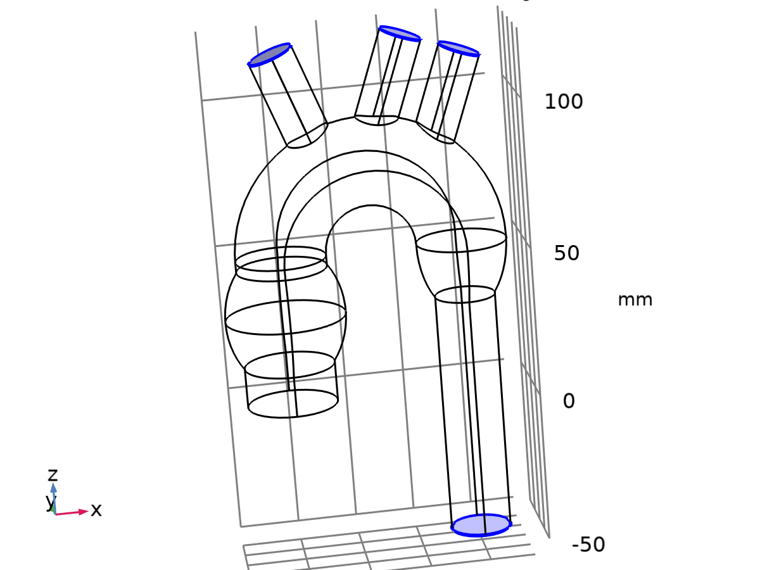

Outlet 2

Selection

|  |  |
| --- | --- |
| Geometric entity level | Boundary |
| Selection | Geometry geom1: Dimension 2: Boundaries 12, 31, 38, 41 |

Equations





#### Boundary Condition

Settings

| **Description** | **Value** |
| --- | --- |
| Boundary condition | Pressure |

#### Pressure Conditions

Settings

| **Description** | **Value** | **Unit** |
| --- | --- | --- |
| Pressure | Static |  |
| Pressure | Pout_max | Pa |
| Normal flow | Off |  |
| Suppress backflow | On |  |

#### Variables

| **Name** | **Expression** | **Unit** | **Description** | **Selection** |
| --- | --- | --- | --- | --- |
| spf.meshVol | meshvol_spatial | m² |  | Boundaries 12, 31, 38, 41 |
| spf.meshVolInt | down(meshvol_spatial) | m³ | Volume of interior mesh element | Boundaries 12, 31, 38, 41 |
| spf.rhoFace | down(spf.rho) | kg/m³ | Density face value | Boundaries 12, 31, 38, 41 |
| spf.umxTnFace | spf.upwind_helpx*spf.nxmesh+spf.upwind_helpy*spf.nymesh+spf.upwind_helpz*spf.nzmesh | m/s | Relative velocity on face | Boundaries 12, 31, 38, 41 |
| spf.p0 | Pout_max | Pa | Pressure | Boundaries 12, 31, 38, 41 |
| spf.out2.Uav | 0 | m/s | Average velocity | Global |
| spf.out2.p0avfdf | 0 | Pa | Average pressure | Global |
| spf.out2.dz | spf.dz | m | Channel thickness | Boundaries 12, 31, 38, 41 |
| spf.out2.Mflow | spf.out2.massFlowRate | kg/s | Mass flow | Global |
| spf.f0 | spf.p0+spf.uNormal*(spf.backflowPenaltyDiff-spf.backflowPenaltyConv)*(spf.uNormal<0) | N/m² | Normal stress | Boundaries 12, 31, 38, 41 |
| spf.uNormal | u*nojac(spf.nxmesh)+v*nojac(spf.nymesh)+w*nojac(spf.nzmesh) | m/s | Normal velocity | Boundaries 12, 31, 38, 41 |
| spf.out2.c_here | 144/spf.epsilon_p | 1 | Intermediate variable | Boundaries 12, 31, 38, 41 |
| spf.backflowPenaltyDiff | spf.out2.c_here*min((down(spf.mu)+spf.muT)*spf.meshVol/spf.meshVolInt,down(spf.rho)*abs(spf.uNormal)/down(spf.epsilon_p)) | Pa·s/m | Backflow penalty parameter, diffusive contribution | Boundaries 12, 31, 38, 41 |
| spf.backflowPenaltyConv | spf.rhoFace*spf.umxTnFace/spf.epsilon_p^2 | kg/(m²·s) | Backflow penalty parameter, convective contribution | Boundaries 12, 31, 38, 41 |
| spf.out2.upwind_ns | spf.backflowPenaltyConv*spf.uNormal | Pa | Upwind term | Boundaries 12, 31, 38, 41 |
| spf.out2.volumeFlowRate | spf.out2.intop(u*spf.nxmesh+v*spf.nymesh+w*spf.nzmesh) | m³/s | Outward volume flow rate across feature selection | Global |
| spf.out2.massFlowRate | spf.out2.intop(spf.rho*(u*spf.nxmesh+v*spf.nymesh+w*spf.nzmesh)) | kg/s | Outward mass flow rate across feature selection | Global |
| spf.out2.pAverage | spf.out2.aveop(p) | Pa | Pressure average over feature selection | Global |

#### Weak Expressions

| **Weak expression** | **Integration order** | **Integration frame** | **Selection** |
| --- | --- | --- | --- |
| -spf.f0*(test(u)*spf.nxmesh+test(v)*spf.nymesh+test(w)*spf.nzmesh) | 2 | Spatial | Boundaries 12, 31, 38, 41 |

## Mesh 1

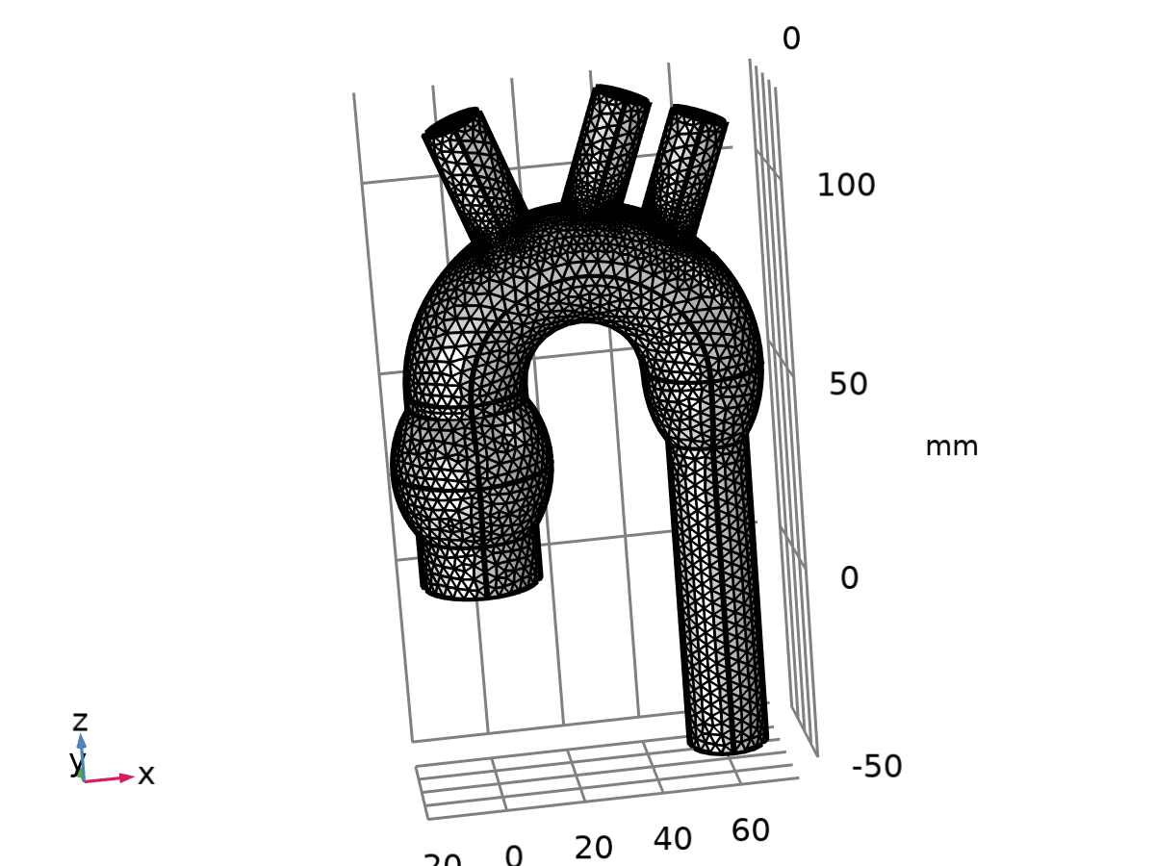

Mesh 1

Mesh statistics

| **Description** | **Value** |
| --- | --- |
| Status | Complete mesh |
| Mesh vertices | 22946 |
| Tetrahedra | 73471 |
| Pyramids | 490 |
| Prisms | 16214 |
| Number of elements | 90175 |
| Minimum element quality | 0.11 |
| Average element quality | 0.69 |
| Element volume ratio | 4.742E-4 |
| Mesh volume | 1.631E5 mm³ |

### Size (size)

Settings

| **Description** | **Value** |
| --- | --- |
| Calibrate for | Fluid dynamics |
| Maximum element size | 6.16 |
| Minimum element size | 1.85 |
| Curvature factor | 0.7 |
| Resolution of narrow regions | 0.6 |
| Maximum element growth rate | 1.2 |
| Predefined size | Coarse |

### Size 1 (size1)

Selection

|  |  |
| --- | --- |
| Geometric entity level | Boundary |
| Selection | Geometry geom1: Dimension 2: Boundaries 1–6, 8–11, 13–30, 32–37, 39–40, 42–45 |

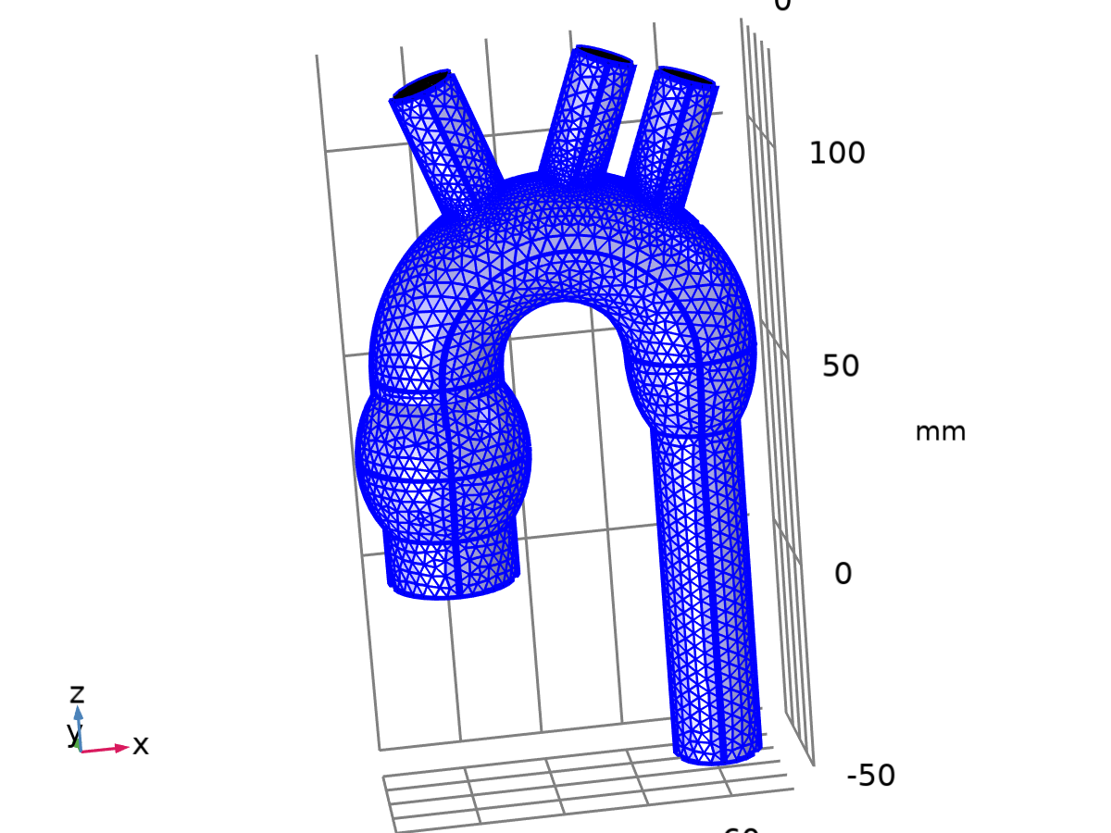

Size 1

Settings

| **Description** | **Value** |
| --- | --- |
| Calibrate for | Fluid dynamics |
| Maximum element size | 3.27 |
| Minimum element size | 0.616 |
| Curvature factor | 0.5 |
| Resolution of narrow regions | 0.8 |
| Maximum element growth rate | 1.13 |
| Predefined size | Fine |

### Corner Refinement 1 (cr1)

Selection

|  |  |
| --- | --- |
| Geometric entity level | Domain |
| Selection | Geometry geom1: Dimension 3: Domain 1 |

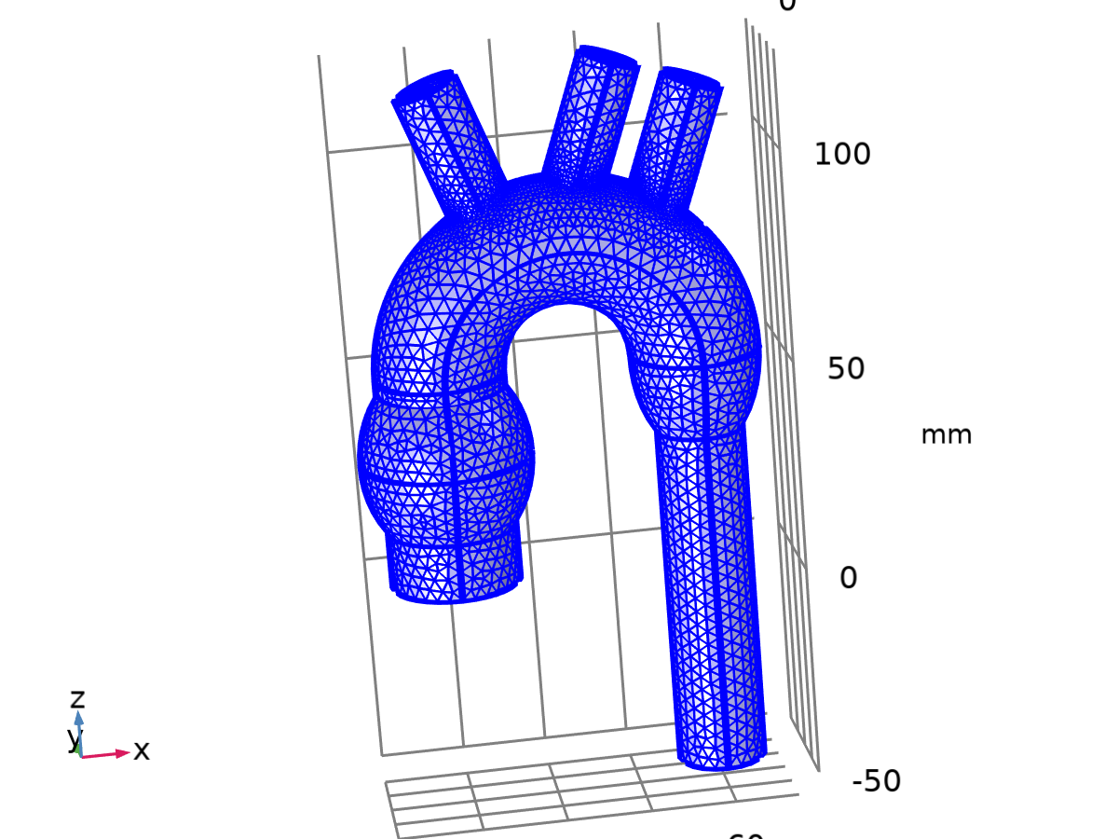

Corner Refinement 1

### Free Tetrahedral 1 (ftet1)

Selection

|  |  |
| --- | --- |
| Geometric entity level | Domain |
| Selection | Remaining |



Free Tetrahedral 1

Settings

| **Description** | **Value** |
| --- | --- |
| Avoid inverted curved elements | On |

Information

| **Description** | **Value** |
| --- | --- |
| Last build time | 4 seconds |
| Built with | COMSOL 6.2.0.339 (win64), Jun 18, 2024, 4:49:39 PM |

### Boundary Layers 1 (bl1)

Selection

|  |  |
| --- | --- |
| Geometric entity level | Domain |
| Selection | Geometry geom1: Dimension 3: Domain 1 |



Boundary Layers 1

Information

| **Description** | **Value** |
| --- | --- |
| Handling of sharp edges | Trimming |
| Last build time | 9 seconds |
| Built with | COMSOL 6.2.0.339 (win64), Jun 18, 2024, 4:49:48 PM |

#### Boundary Layer Properties 1 (blp1)

Selection

|  |  |
| --- | --- |
| Geometric entity level | Boundary |
| Selection | Geometry geom1: Dimension 2: Boundaries 1–6, 8–11, 13–30, 32–37, 39–40, 42–45 |



Boundary Layer Properties 1

Settings

| **Description** | **Value** |
| --- | --- |
| Number of layers | 2 |
| Thickness adjustment factor | 5 |

# Study 1

Computation information

|  |  |
| --- | --- |
| Computation time | 49 s |

## Stationary

Study settings

| **Description** | **Value** |
| --- | --- |
| Include geometric nonlinearity | Off |

Physics and variables selection

| **Physics interface** | **Solve for** | **Equation form** |
| --- | --- | --- |
| Laminar Flow (spf) | On | Automatic (Stationary) |

Store in output

| **Interface** | **Output** | **Selection** |
| --- | --- | --- |
| Laminar Flow (spf) | Physics controlled |  |

Mesh selection

| **Component** | **Mesh** |
| --- | --- |
| Component 1 | Mesh 1 |

## Solver Configurations

### Solution 1

#### Compile Equations: Stationary (st1)

Study and step

| **Description** | **Value** |
| --- | --- |
| Use study | Study 1 |
| Use study step | Stationary |

Log

<---- Compile Equations: Stationary in Study 1/Solution 1 (sol1) ---------------

Started at Jun 21, 2024, 4:44:18 PM.

Geometry shape function: Linear Lagrange

Running on Intel64 Family 6 Model 142 Stepping 10, GenuineIntel.

Using 1 socket with 4 cores in total on Francesco.

Available memory: 16.26 GB.

Time: 2 s.

Physical memory: 1.44 GB

Virtual memory: 1.57 GB

Ended at Jun 21, 2024, 4:44:19 PM.

----- Compile Equations: Stationary in Study 1/Solution 1 (sol1) -------------->

#### Dependent Variables 1 (v1)

General

| **Description** | **Value** |
| --- | --- |
| Defined by study step | Step 1: Stationary |

Log

<---- Dependent Variables 1 in Study 1/Solution 1 (sol1) -----------------------

Started at Jun 21, 2024, 4:44:19 PM.

Solution time: 0 s.

Physical memory: 1.45 GB

Virtual memory: 1.57 GB

Ended at Jun 21, 2024, 4:44:19 PM.

----- Dependent Variables 1 in Study 1/Solution 1 (sol1) ---------------------->

##### Pressure (comp1.p) (comp1_p)

General

| **Description** | **Value** |
| --- | --- |
| Field components | comp1.p |

##### Velocity Field (comp1.u) (comp1_u)

General

| **Description** | **Value** |
| --- | --- |
| Field components | {comp1.u, comp1.v, comp1.w} |
| Internal variables | comp1.spf.isFluidHasBeenSolved |

##### Help Ode Variable for Fully Developed Flow (comp1.spf.inl1.Pinlfdf) (comp1_spf_inl1_Pinlfdf)

General

| **Description** | **Value** |
| --- | --- |
| State components | comp1.spf.inl1.Pinlfdf |

#### Stationary Solver 1 (s1)

General

| **Description** | **Value** |
| --- | --- |
| Defined by study step | Step 1: Stationary |

Log

<---- Stationary Solver 1 in Study 1/Solution 1 (sol1) -------------------------

Started at Jun 21, 2024, 4:44:20 PM.

Nonlinear solver

Number of degrees of freedom solved for: 91785 (plus 1 internal DOFs).

Nonsymmetric matrix found.

Scales for dependent variables:

Pressure (comp1.p): 0.12

Velocity Field (comp1.u): 0.48

Help Ode Variable for Fully Developed Flow (comp1.spf.inl1.Pinlfdf): 1

Orthonormal null-space function used.

Iter      SolEst      ResEst     Damping    Stepsize #Res #Jac #Sol LinIt   LinErr   LinRes

   1          81     1.4e+04   0.0100000          82    2    1    2     1  0.00065  0.00066

   2         6.7     1.5e+04   0.1000000         7.4    3    2    5     3  0.00013  0.00014

   3         2.2     2.4e+05   1.0000000        0.77    4    3    8    13    0.066     0.07

   4       0.088     1.8e+05   0.2724740        0.12    6    4   12    50    0.084    0.014

   5       0.034     7.5e+04   0.8819198        0.11    7    5   14    59     0.11        -

   6       0.025     4.9e+04   0.8512420       0.068    8    6   16    68    0.085        -

   7      0.0095     4.7e+04   1.0000000       0.034    9    7   19    74    0.088        -

   8      0.0036     1.8e+04   1.0000000       0.017   10    8   22    79    0.026        -

   9      0.0012     5.6e+03   1.0000000      0.0056   11    9   25    82    0.012        -

  10      0.0051     9.3e+02   1.0000000        0.02   13   10   28    85   0.0055        -

  11      0.0018     4.9e+02   1.0000000      0.0088   14   11   31    88    0.019        -

  12     0.00063     1.5e+02   1.0000000      0.0029   16   12   34    91   0.0073        -

Solution time: 47 s.

Physical memory: 1.78 GB

Virtual memory: 1.8 GB

Ended at Jun 21, 2024, 4:45:07 PM.

----- Stationary Solver 1 in Study 1/Solution 1 (sol1) ------------------------>

##### Advanced (aDef)

Assembly settings

| **Description** | **Value** |
| --- | --- |
| Reuse sparsity pattern | On |

##### Fully Coupled 1 (fc1)

General

| **Description** | **Value** |
| --- | --- |
| Linear solver | AMG, fluid flow variables (spf) |

Method and termination

| **Description** | **Value** |
| --- | --- |
| Initial damping factor | 0.01 |
| Maximum number of iterations | 100 |

##### AMG, fluid flow variables (spf) (i1)

General

| **Description** | **Value** |
| --- | --- |
| Nonlinear-based error norm | On |
| Maximum number of iterations | 1000 |

Error

| **Description** | **Value** |
| --- | --- |
| Factor in error estimate | 20 |

###### Multigrid 1 (mg1)

General

| **Description** | **Value** |
| --- | --- |
| Solver | Smoothed aggregation AMG |
| Maximum number of DOFs at coarsest level | 80000 |
| Strength of connections | 0.02 |
| Construct prolongators componentwise | On |
| Prolongator smoothing | Off |

Presmoother (pr)

SCGS 1 (sc1)

Main

| **Description** | **Value** |
| --- | --- |
| Sweep type | SSOR |
| Number of iterations | 0 |
| Vanka | On |
| Variables | Help Ode Variable for Fully Developed Flow (comp1.spf.inl1.Pinlfdf) |
| Use approximate factorization | On |
| Use Schur complement approximation for blocks with size larger than | 1000 |

Postsmoother (po)

SCGS 1 (sc1)

Main

| **Description** | **Value** |
| --- | --- |
| Sweep type | SSOR |
| Number of iterations | 1 |
| Vanka | On |
| Variables | Help Ode Variable for Fully Developed Flow (comp1.spf.inl1.Pinlfdf) |
| Use approximate factorization | On |
| Use Schur complement approximation for blocks with size larger than | 1000 |

Coarse Solver (cs)

Direct 1 (d1)

General

| **Description** | **Value** |
| --- | --- |
| Solver | PARDISO |
| Pivoting perturbation | 1E-13 |

# Results

## Datasets

### Study 1/Solution 1

Solution

| **Description** | **Value** |
| --- | --- |
| Solution | Solution 1 (sol1) |
| Component | Component 1 (comp1) |

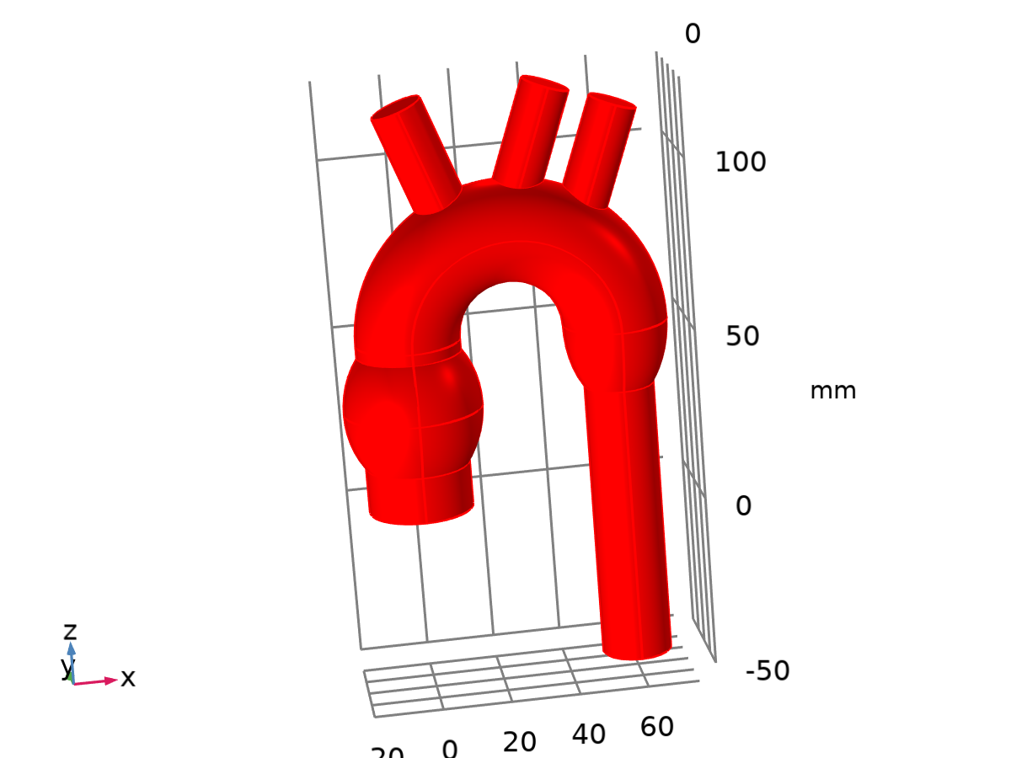

Dataset: Study 1/Solution 1

### Exterior Walls

Data

| **Description** | **Value** |
| --- | --- |
| Dataset | Study 1/Solution 1 (sol1) |

Parameterization

| **Description** | **Value** |
| --- | --- |
| x- and y-axes | Surface parameters |

## Plot Groups

### Velocity (spf)

[COMSOLlink[]]

Slice: Velocity magnitude (m/s) Streamline: Velocity field

### Pressure (spf)

[COMSOLlink[]]

Surface: Pressure (Pa)